Experimental task n. 7

Pavel Ondračka
324363
18.03.2010

subject: Operational amplifier.

Introduction: An operational amplifier is a DC-coupled high-gain electronic voltage amplifier with a differential input and, usually, a single-ended output. An op-amp produces an output voltage that is typically millions of times larger than the voltage difference between its input terminals. Typically the op-amp's very large gain is controlled by negative feedback, which largely determines the magnitude of its output ("closed-loop") voltage gain in amplifier applications, or the transfer function required (in analog computers). Without negative feedback, and perhaps with positive feedback for regeneration, an op-amp essentially acts as a comparator. High input impedance at the input terminals (ideally infinite) and low output impedance at the output terminal(s) (ideally zero) are important typical characteristics.

a) Operational amplifier connected in the inverting amplifier configuration.
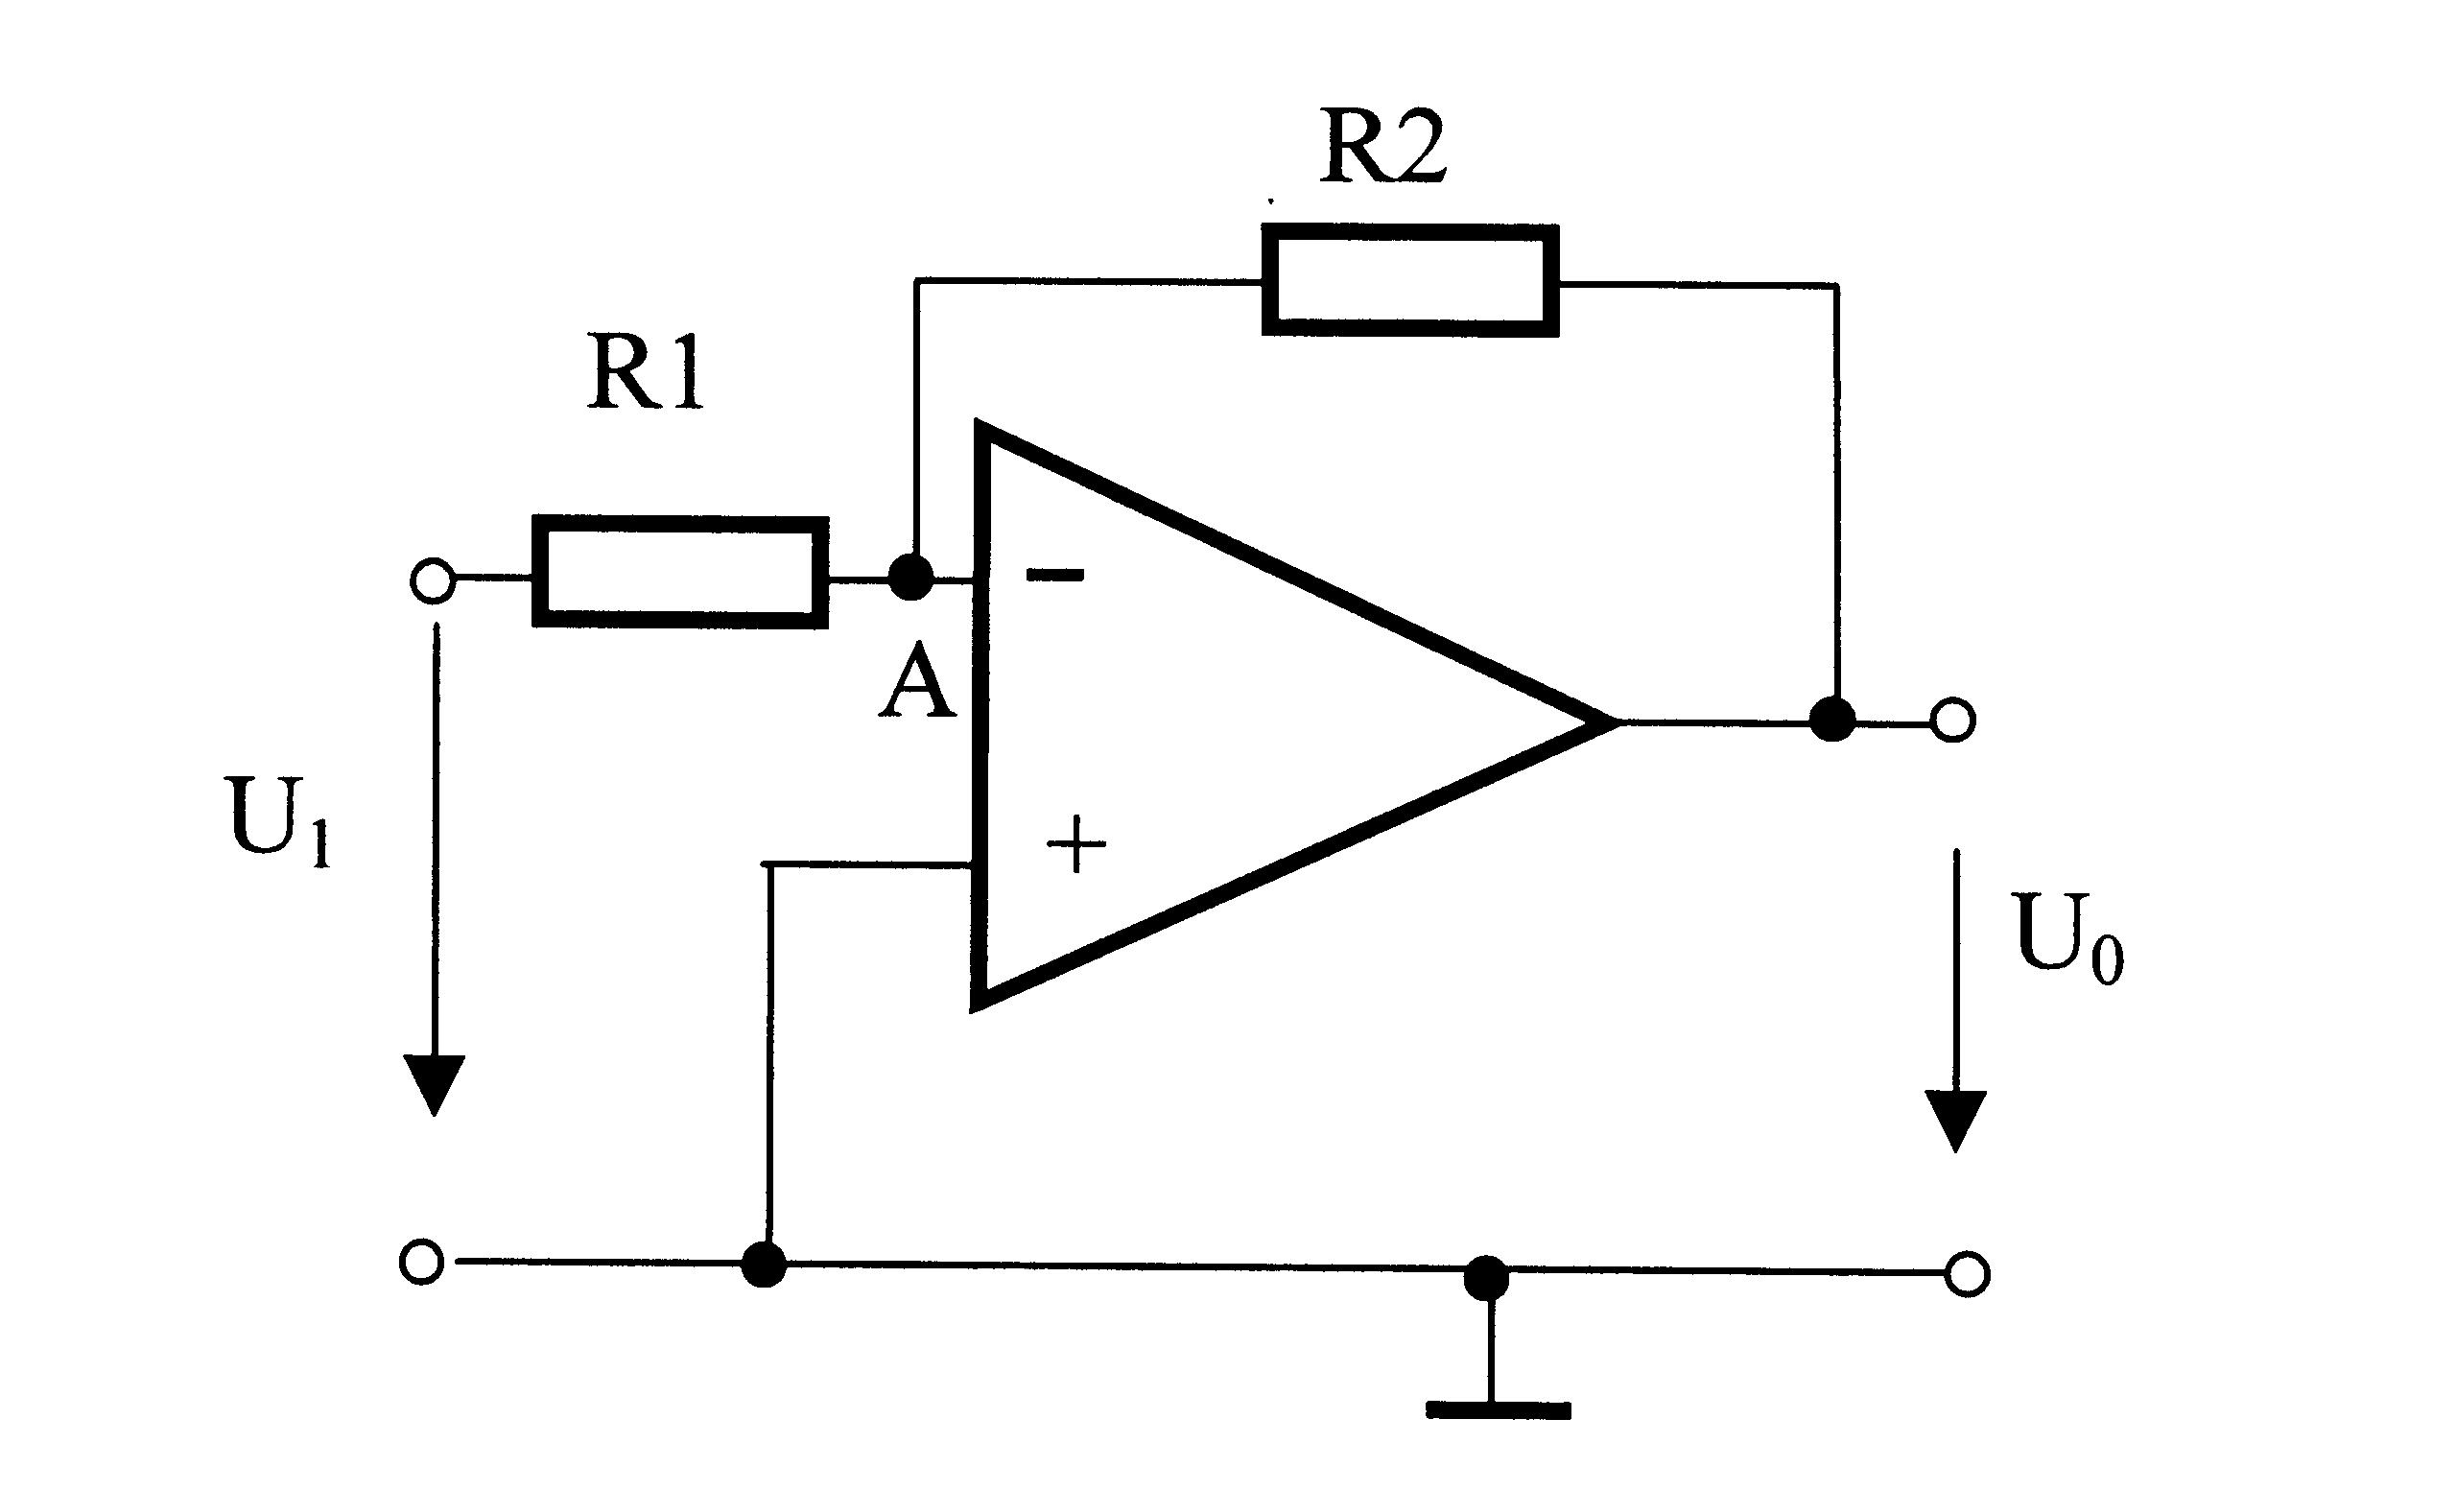
Task 1) connect the operational amplifier in the inverting configuration. Choose such resistors that the configuration amplifies the input signal by ca 2 and verify whether the circuitry works well. Several pairs of the input and output DC voltages should be
measured and the slope of the measured dependence should agree with the calculated
gain.

With the inverting amplifier configuration, the amplifier amplifies the input voltage according to the relation:
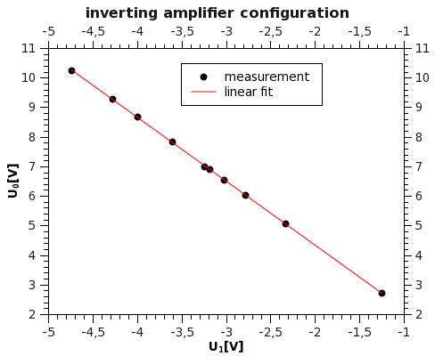

slope = A_{u,max} = (-2,164 ± 0,005)
y-intercept = (0,01 ± 0,02) V

Task 2) determine the bandwidth of the particular operational amplifier. Bandwidth is the
frequency range where the op-amp amplifies the signal, conventionally range where the gain does not drop below A_{u,max} / sqrt(2). A_{u,max} is the maximum gain for low frequencies
measured in task 1. Connect AC signal to the circuitry and measure the dependence of
the gain on the frequency by means of an oscilloscope. From a graph showing this
dependence define the op-amp bandwidth.
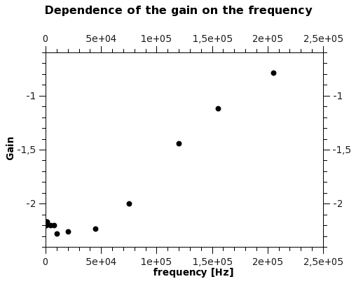
A_{u,max}/sqrt(2) = -1,530 ± 0,003

From the plot we can see, that with the higher frequencies the dependency is approx. linear. And from interpolation we can gain the bandwidth.

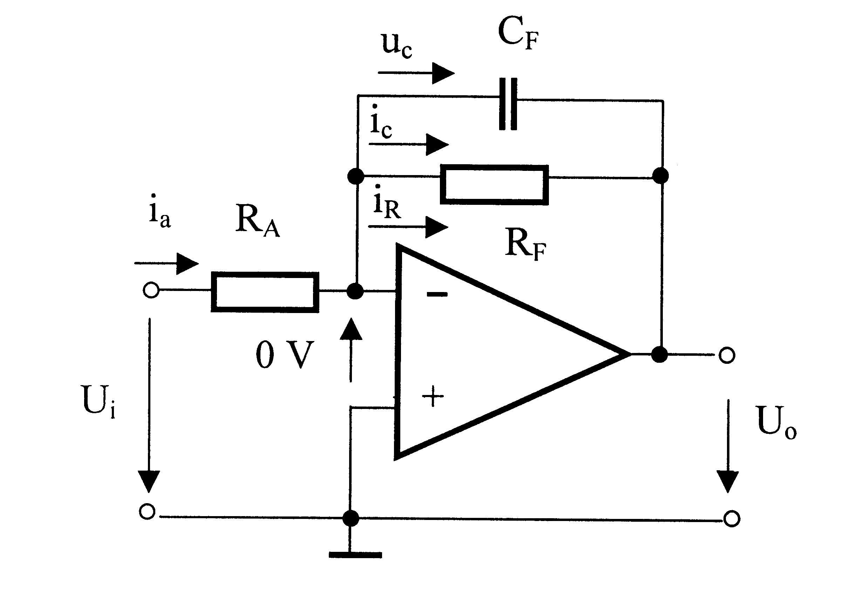
Bandwidth = 113kHz

b) Low-pass filter

Task 3) measure the dependence of the gain of the low-pass filter

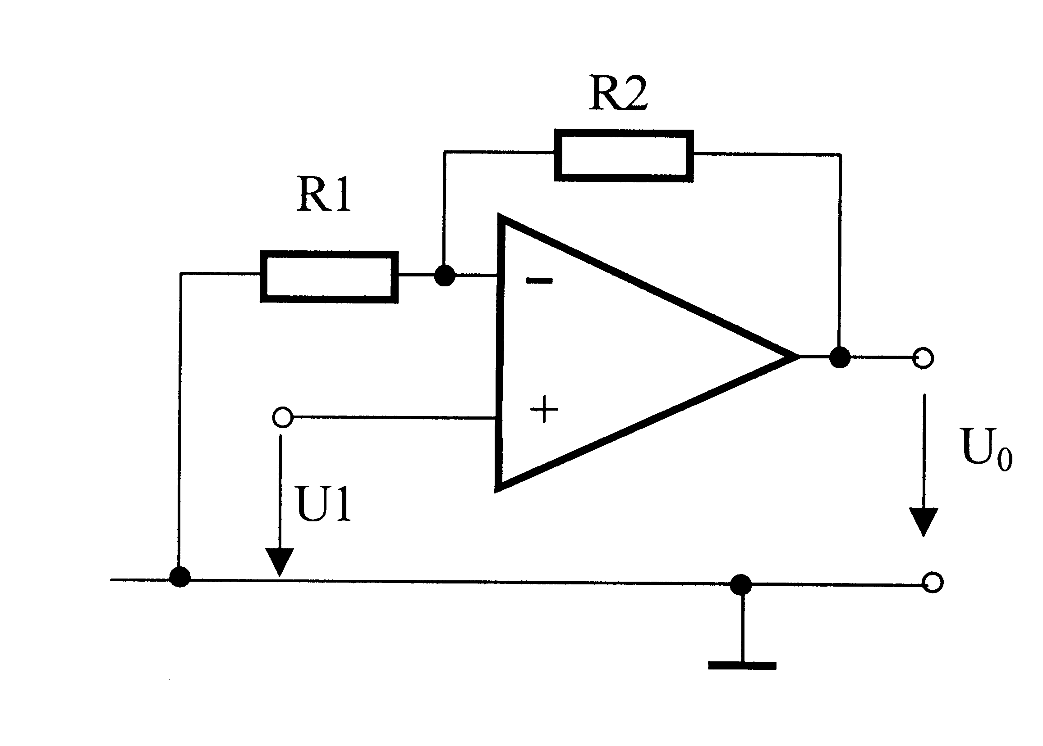
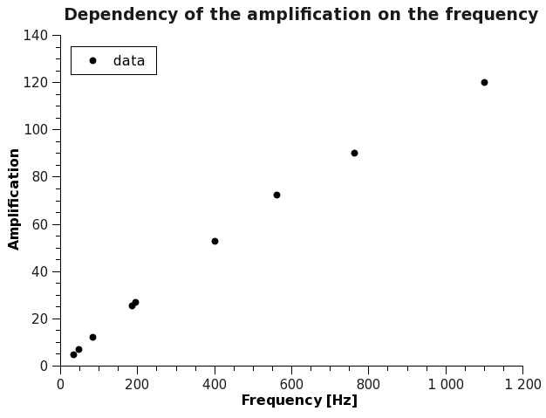
c) Non-inverting amplifier configuration

Task 4) The input voltage is connected to the non- inverting input whereas the inverting input is connected to ground through the resistor R₁ . The feedback is connected to the inverting input through the resistor R₂ . By means of a procedure analogical to the procedure used in the task 1 you should calculate what makes the configuration.

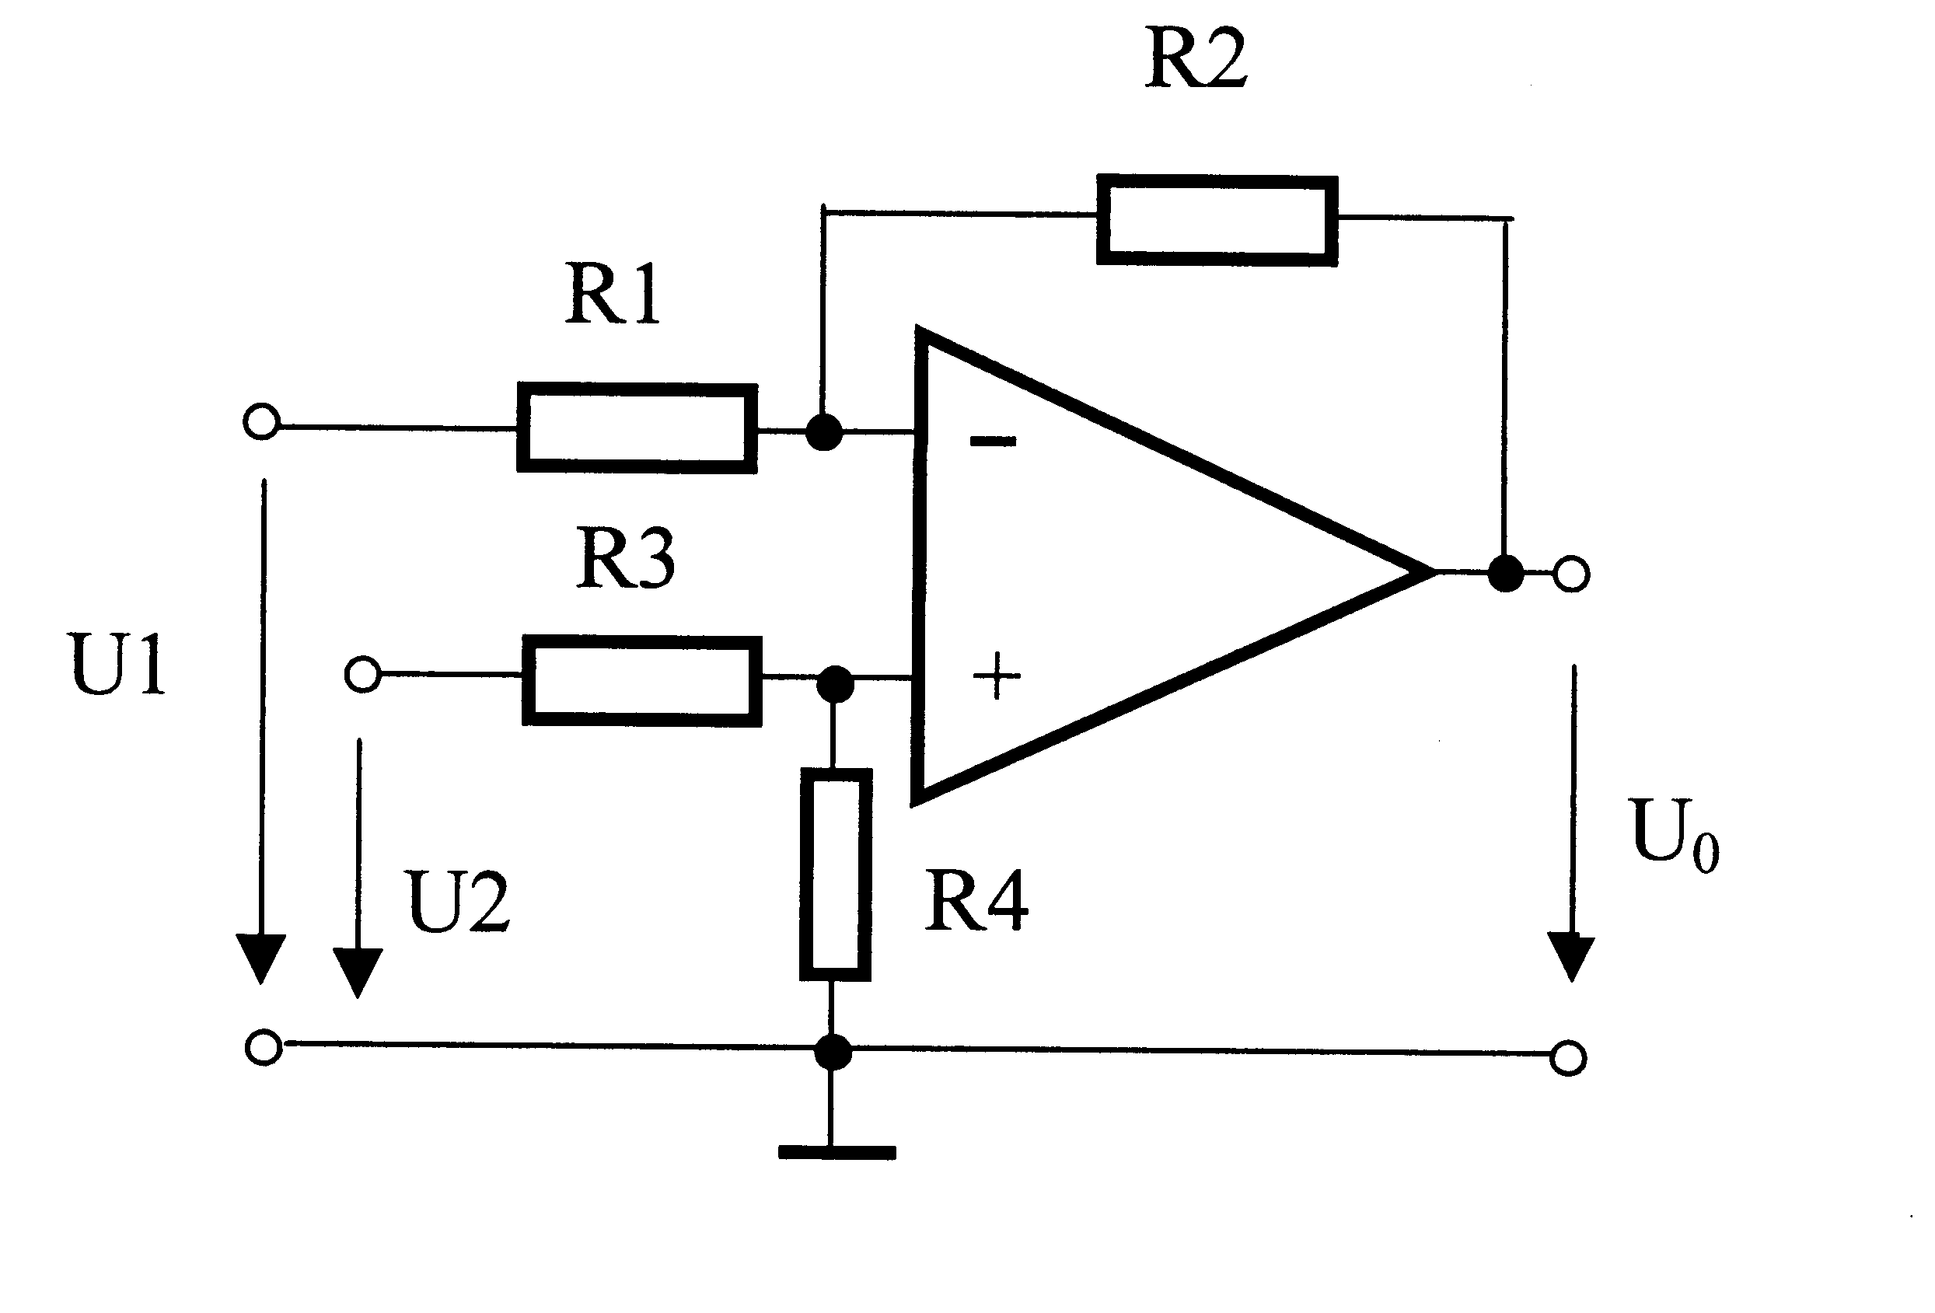
d) Differential amplifier
Task 5) Verify whether this configuration amplifies the difference between two input
voltages in accordance with the equation :

Resistors were chosen:
R₁ = R₃ = 10 kΩ
R₂ = R₄ = 22 kΩ,
so the equation is simplified:

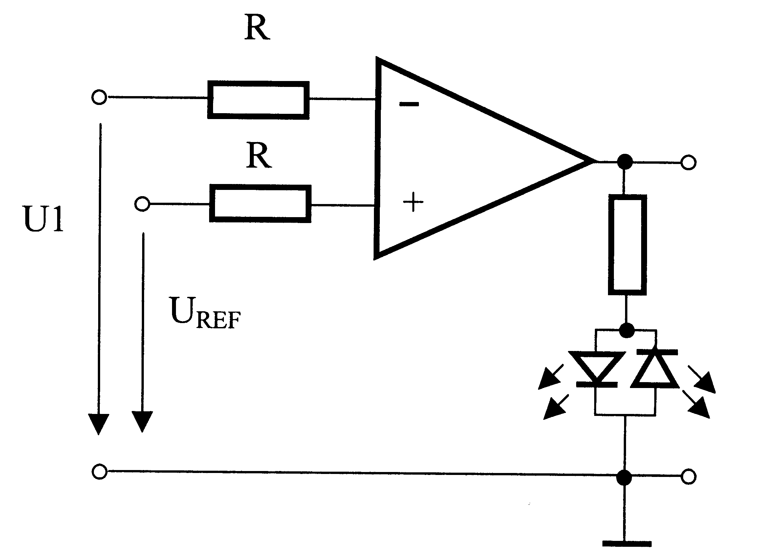
e) Voltage comparator

task 6) Since operational amplifier multiplies the difference between the input potential by a very high number, it is very sensitive tool to compare two signals. Explore behavior of this comparator.

If U₁ > U_{ref} - U₀ is -12,12 V and greed LED is lit.
If U1 < Uref - U0 is 13,65 V and red LED is lit.

Conclusion: During this task, I was able to confirm that operational amplifier was behaving in accordance with all mentioned amplifying equations. I was also able to successfully measure dependency of the amplification on the frequency and define the bandwidth.

